National College of Computer Studies

Paknajol, Kathmandu

**Lab Report on**

**Theory of Computation**

**Submitted by: Submitted to:**

Atullya Maharjan Prashant Gautam

BSc. CSIT 4th Semester NCCS

Roll. No: 05

1. **Write a Program to find prefixes, suffixes and substrings from a given string.**

#include <iostream>

#include <string>

using namespace std;

int main() {

string str;

cout << "Enter a string: ";

cin >> str;

cout << "Substring: ";

for (int i = 0; i < str.length(); i++) {

for (int j = i; j < str.length(); j++) {

cout << str.substr(i, j - i + 1) << " ";

}

}

cout << endl;

cout << "Prefix: ";

for (int i = 0; i < str.length(); i++) {

cout << str.substr(0, i + 1) << " ";

}

cout << endl;

cout << "Suffix: ";

for (int i = 0; i < str.length(); i++) {

cout << str.substr(i) << " ";

}

cout << endl;

return 0;

}

OUTPUT

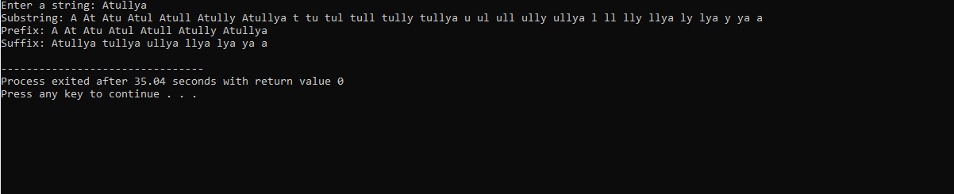

1. **Write a Program to validate C identifiers and keywords.**

#include <iostream>

#include <string.h>

#include <set>

using namespace std;

int main()

{

char str[100];

int i, l, flag = 0;

cout << "Enter a string: ";

cin >> str;

l = strlen(str);

if (!((str[0] >= 'a' && str[0] <= 'z') || (str[0] >= 'A' && str[0] <= 'Z') || str[0] == '_')) {

cout << "Invalid identifier" << endl;

return 0;

}

// Check if remaining characters are letters, digits or underscore

for (i = 1; i < l; i++)

{

if (!((str[i] >= 'a' && str[i] <= 'z') || (str[i] >= 'A' && str[i] <= 'Z') || (str[i] >= '0' && str[i] <= '9') || str[i] == '_'))

{

cout << "Invalid identifier" << endl;

return 0;

}

}

set<string> keywords = {"auto", "break", "case", "char", "const", "continue", "default", "do", "double", "else", "enum", "extern", "float", "for", "goto", "if", "int", "long", "register", "return", "short", "signed", "sizeof", "static", "struct", "switch", "typedef", "union", "unsigned", "void", "volatile", "while"};

if (keywords.find(str) != keywords.end()) {

cout << "Keyword" << endl;

}

else {

cout << "Valid identifier" << endl;

}

return 0;

}

OUTPUT





